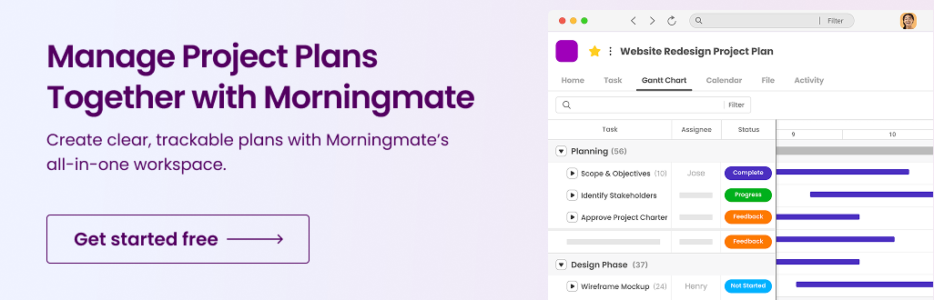

PROJECT MANAGEMENT PLAN TEMPLATE

Project Objectives and KPIs

Project Purpose
Project Goal | Project Objectives
Goal 1
Goal 2
Goal 3

Category | Success Metric | Measurement Method | Target | Assigned to
Scope

Schedule

Budget

Quality

Stakeholder satisfaction

Risk management

Resource utilization

Compliance

Project Scope and Deliverables

Scope Baseline
Task | Dependencies | Deliverables | Acceptance Criteria

*For each task identified, list the resources allocated to complete the task.
Task | Resource requirements

Exclusions, Assumptions and Constraints
Exclusions

Assumptions

Constraints

️ Project Timeline and Milestones

Milestone | Description | Delivery Date
 |  | xx/yy/zz

Team Roles and Responsibilities

Name | Role | Responsibilities

Budget Summary

Task | Labor Costs | Material Costs | Other Costs | Budget | Actual

️ Risks and Assumptions

Risk Matrix |  | Severity
 |  | Insignificant | Minor | Moderate | Major | Severe
Likelihood | Almost Certain | Medium | High | Very High | Very High | Very High
 | Likely | Medium | High | High | Very High | Very High
 | Possible | Low | Medium | High | High | Very High
 | Unlikely | Low | Low | Medium | Medium | High
 | Rare | Low | Low | Low | Low | Medium

Risk | Likelihood | Impact | Response | Risk Level | Risk Owner
1 |  | Schedule |  | High | Risk owner name

️Communication Brief & Stakeholders Management

Name | Role | Power | Interest | Contact information

Level of Influence |  | Keep Satisfied |  |  |  |  | Manage Closely
 | High
 | Medium
 | Low
 |  | Monitor |  |  |  |  | Keep Informed
 |  | Low |  |  | Medium |  |  | High
 |  |  | Level of Interest

DISCLAIMER

Any templates, or resources provided by Morningmate are intended for general informational purposes only. While we aim to keep all materials accurate and up to date, Morningmate makes no representations or warranties of any kind, express or implied, about the completeness, reliability, accuracy, or suitability of the content. Use of this information is at your own discretion and risk. Morningmate is not liable for any loss or damage arising from the use of these materials.

