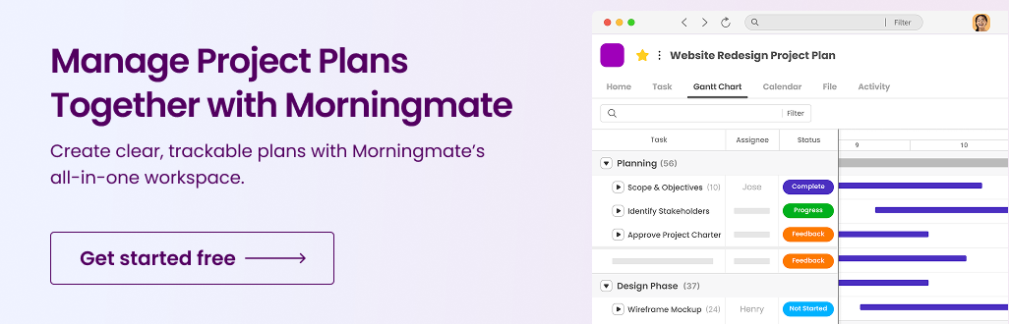
DISCLAIMER

Any templates, or resources provided by Morningmate are intended for general informational purposes only. While we aim to keep all materials accurate and up to date, Morningmate makes no representations or warranties of any kind, express or implied, about the completeness, reliability, accuracy, or suitability of the content. Use of this information is at your own discretion and risk. Morningmate is not liable for any loss or damage arising from the use of these materials.

Communication Plan Template

Objectives | Goals | How to measure
 | • List your goals here | •

Audience

 | Know | Feel | Do
Individual/ Group 1
Individual/ Group 2
Individual/ Group 3

Overview

Communication Type | Purpose | Audience | Frequency | Format/  Channel | Owner | Status/Notes
Project Kick-off Meeting | Align team on project goals & timeline | Project Team, Stakeholders | One-time | In-person / Video Call | Project Manager | Scheduled for [Insert Date]
Weekly Status Report | Update on progress, issues, milestones | Project Team, Sponsor | Weekly | Morningmate | Team Lead | First report due [Insert Date]
Stakeholder Update | Inform stakeholders of high-level progress | Key Stakeholders | Bi-weekly | Presentation/Morningmate | Communication Officer | Template approved
Risk Management Alert | Communicate risks & mitigation plans | Project Team | As needed | Instant Messaging/ Morningmate | Risk Manager | In use
Change Request Notification | Inform about changes in scope/timeline | Stakeholders, Team | As needed | Change Log/ Morningmate | Project Manager | To be scheduled
Project Review Meeting | Review outcomes & lessons learned | Project Team, Sponsors | End of project | Meeting (In-person/Virtual) | Project Manager | To be scheduled

